Signal Processing Application of FFT

Ruquiya Nasir Ladawala
Faculty of computing
Capital University of Science and Technology
Rawalpindi, Pakistan
ruquiyanasirlakda@gmail.com

Laiba Shahzadi
Faculty of computing
Capital university of Science and Technology
Rawalpindi , Islambad
laibashahzadi333@gmail.com

Abstract— The research explores the application of the Fast Fourier Transform (FFT) to remove unwanted frequencies from signals using Finite Impulse Response (FIR) filters. It delves into the mathematical principles of the Discrete Fourier Transform (DFT) and FFT, comparing Infinite Impulse Response (IIR) and FIR filters. Through practical implementation, the study aims to demonstrate the effectiveness of FFT in signal processing. Expected outcomes include a deeper understanding of FFT and filters and contributions to improved signal processing techniques.
Keywords—FFT, FIR, IIR, DFT

Introduction (Heading 1)
The Fast Fourier Transform (FFT) is a mathematical transform that decomposes functions depending on space or time into functions depending on spatial or temporal frequency. It is a highly optimized implementation of the Discrete Fourier Transform (DFT), converting discrete signals from the time domain to the frequency domain. FFT computations provide information about the frequency content, phase, and other properties of the signal. The FFT is a crucial measurement method in audio and acoustics, converting a signal into individual spectral components to provide frequency information. However, the FFT assumes the sampled signal segment is repeated periodically, making it suitable only for periodic signals. This research aims to understand how FFT can be used to remove unwanted frequencies from a signal, comparing DFT and FFT and identifying the appropriate filter types for different applications

OBJECTIVE

MOTTO
The only motto of this research is to create the concept of Fast Fourier Transform and also to make one understand how Fast Fourier Transform can be used in the simplest of ways to remove unwanted frequencies in a given signal.

POINTS
- To clearly understand the concept and difference between of DFT and FFT.
- To clearly identify between two filters to determine which to use when and why?
- FIR and IIR uses and difference.
- To implement an application after identifying the correct requirements to easily and simply remove unwanted frequencies from a given signal.

Literature Review

Analysis of signal noise reduction by using filters
This paper designs and compares three different filtering methods to reduce the effects of noise in medical health applications such as an electrocardiogram (ECG). The low pass filter excludes the noise at a low-level, moving average filter takes average values of the signal, and Finite Impulse Response (FIR) removes the high frequency components from the ECG and gives the low frequency component which is the desired information signal. Simulation results reveal that FIR filter performs better by reducing the attenuation in the ECG signal than low pass filter and moving average filters and is appropriate for the medical health applications.[1]

Signal Processing Technique to remove the effect of dispersion from guided wave signals
If a guided wave mode is dispersive, a pulse of energy will spread out in space and time as it propagates. For a long-range guided wave inspection application, this constrains the choice of operating point to regions on the dispersion curves where dispersion effects are small. A signal processing technique is presented that enables this constraint on operating point to be relaxed. The theoretical basis of the technique is described and an efficient numerical implementation is presented. But has lot of limitations and requires more work [2]

A hybird signal pre-processing approch in processing ultasonic signals with noise
Ultrasonic techniques have the potential to be used to detect sub-surface defects in aluminum castings. However, ultrasonic sensing techniques have not been successfully. Hence, there is a need to process noisy ultrasonic signals to identify defects within the rough surface castings. This paper documents an investigation of ultrasonic signal analysis using hybrid signal pre-processing approaches for the purpose of detecting defects from noisy ultrasonic signals The hybrid pre-processing techniques utilized various combinations of fast Fourier transform (FFT), wavelet transform (WT) and principal component analysis.[3]

Reducing noise by repitition: introduction to signal averaging
This paper describes theory and experiments, taken from biophysics and physiological measurements, to illustrate the technique of signal averaging. In the process, students are introduced to the basic concepts of signal processing, such as digital filtering, Fourier transformation, baseline correction, pink and Gaussian noise, and the cross- and autocorrelation functions. They also learn about some of the pitfalls encountered in quantifying the signal and noise components for a meaningful computation of the signal-to-noise ratio [4]

A Novel Methodology for digital removal of perodic noise using Fast Fourier Transform
An efficient methodology to remove periodic noise from digital images is proposed. The methodology steps are discussed, analyzed and implemented. Color image is to be converted to gray image, and then fast Fourier transform
is to be applied on the gray image. The magnitude of applying FFT is to be analyzed in order to get the periodic filter, which is to be correlated with the
magnitude matrix, and the output of correlation is to be used with the angle matrix to get the un noisy gray image. Experimental results are shown and they demonstrate the efficiency of using that the proposed filter for removing high and low frequencies. [5]

Fractional Fourier Transform as a signal processing tool.
Fractional Fourier transform (FRFT) is a generalization of the Fourier transform, rediscovered many times over the past 100 years. In this paper, they provide an overview of recent contributions pertaining to the FRFT. Specifically, the paper is geared toward signal processing practitioners by emphasizing the practical digital realizations and applications of the FRFT. It discusses three major topics. First, the manuscripts relates the FRFT to other mathematical transforms. Second, it discusses various approaches for practical realizations of the FRFT. Third, we overview the practical applications of the FRFT. And found that Overall, the FRFT is a valuable signal processing tool. Its practical applications are expected to grow significantly in years to come, given that the FRFT offers many advantages over the traditional Fourier analysis. [6]

Noise reduction in audio file using FFT by Python Modules
Future telecommunication relies on advanced noise reduction techniques like Fast Fourier Transform (FFT) and spectral gating to enhance speech communication by suppressing ambient noise. These methods effectively reduce noises such as fan hum, street horns, and dog barks, improving audio clarity. Evaluating the signal-to-noise ratio (SNR) of raw and processed audio confirms the effectiveness of these noise cancellation techniques.[7]

A B-wavelet-based noise-reduction algorithm
A wavelet-based method is introduced for removing structured noise (e.g., impulsive spikes or unwanted harmonic components) from data. For this type of noise, the time- and frequency-localization capabilities of wavelets provide better noise detection and less signal distortion than direct filtering of data. The procedure is applied to time-series data with impulsive noise and transfer-function data with multipath interference. The authors use a single set of scaling and wavelet bases that can effectively represent a wide range of signals, and then they perform noise reducing operations on the scaling and wavelet coefficients.[8]

Frequnecy-Domain processors for efficent removal of Noise and unwanted audio events
They presented theoretical study on Filtering heavily polluted audio signals with low-cut, high-cut or notch filters helps only if the spectrum of disturbances does not overlap the desired signal. Unfortunately, this is rarely the case in real situations. Therefore, using frequency domain methods is the only way to achieve dramatic improvements when cleaning up noisy signals. Spectral denoising works well in the case of broadband, smoothly changing noise, however, the situation become hopeless when the noise character changes abruptly and the S/N ratio is around zero decibels. It’s not implemented yet.[9]

Discrete Fourier transform techniques for noise reducion an ddigital enhancement of analytical signals
Comprehensive details of problem-solving approaches with discrete Fourier transform (DFT) are presented with reference to current separation science applications, which are equally applicable to spectroscopic data. Fourier deconvolution, approximated as a series sum of derivatives allows summarization of tailing Gaussians (or any function convoluted with an exponential function). Peaks buried under the tail even with an area ratio of 100:1 can be exposed. It had limitation in not detecting all unwanted noise.[10]

Methadology
Wondering why we humans were in dire need of FFT even though DFT existed to do the same job? Here are some important factors about FFT.

Fast fourier Transform
• A fast Fourier transform (FFT) is an algorithm that calculates the discrete Fourier transform (DFT) of some sequence and transforms the structure of the cycle of a waveform into sine components.
• A fast Fourier transform can be used in various types of signal processing. It may be useful in reading things like sound waves, or for any image-processing technologies.
• A fast Fourier transform can be used to solve various types of equations, or show various types of frequency activity in useful ways.
• For example, fast Fourier transform might be helpful in sound engineering, seismology or in voltage measurements. 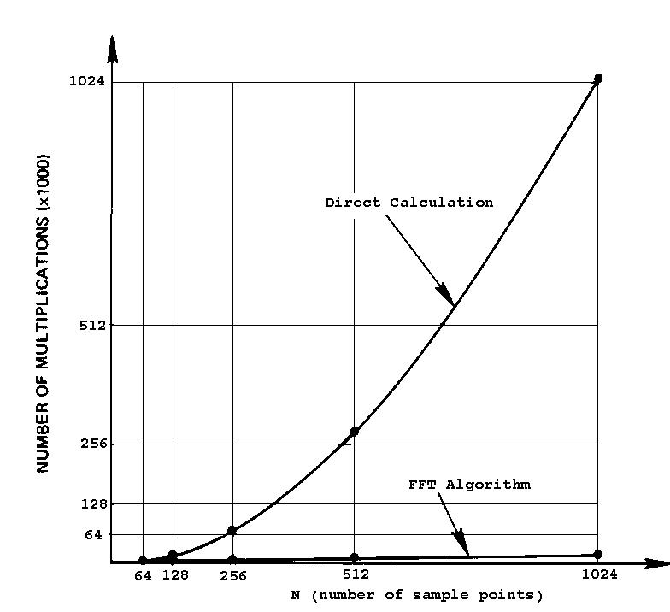
For a sample set of 1024 values, the FFT is 102.4 times faster than the discrete Fourier transform (DFT). The basis for this remarkable speed advantage is the bit-reversal scheme of the CooleyTukey algorithm.

What we did?
Thus, for the application four sinusoidal signals with different frequencies were used. A noisy signal was generated. The four Signals along with noise were added to generate a single signal with different frequency components. The FFT of this signal was computed using fft() function and the frequency spectrum was plotted to visualize the frequency components.
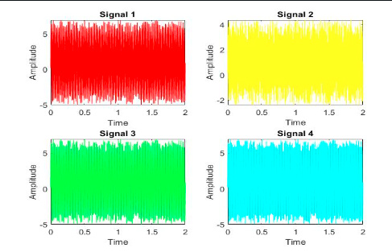
After adding noising signal also adding all the signals together
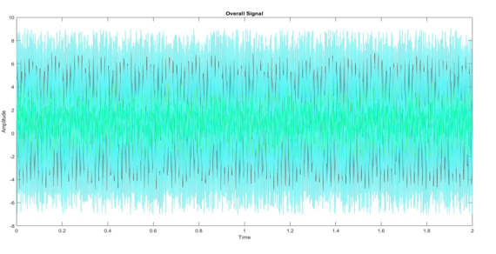
This was the image comparing all the signals generated in the process.
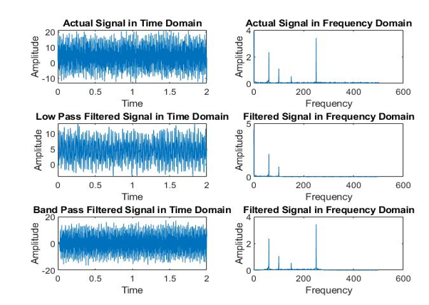

Limitation
We had used FIR filter due to its stability. But the advantage of IIR filters over FIR filters is that IIR filters work faster, and require less memory space. Also only FIR filters can be used with FFT.
The FFT is much faster than the DFT but requires more memory. The FFT can be used to compute the DFT of a sequence that is not a power of two, while the DFT can only be used to compute the DFT of a sequence that is a power of two.

To summarize both FIR and FFT requires more memory

Future Directions:
In future an algorithm should be generated to use IIR filter with FFT. To Increase efficiency of the system. As for a really big project FFT with FIR would require a large amount of memory, where as using IIR filter with FFT will help to rude this limitations.

Conclusion
A detail research was done on FFT and DFT, along with FIR and IIR .After Identifying the requirements an application of filtering unwanted frequencies form a signal using FFT with FIR was implemented on PYTHON. The application included a noisy signal generated and added into four sinusoidal signals. After that the FFT of this signal was computed and then BPF AND LPF was generated

References

- https://ieeexplore.ieee.org/abstract/document/8346412
- https://ieeexplore.ieee.org/abstract/document/1197965
- https://link.springer.com/article/10.1007/s00170-008-1640-0
- https://iopscience.iop.org/article/10.1088/0143-0807/31/3/003/meta
- https://m-hikari.com/ces/ces2014/ces1-4-2014/abueinCES1-4-2014.pdf
- https://www.sciencedirect.com/science/article/abs/pii/S0165168410003956
- https://ebooks.iospress.nl/doi/10.3233/ATDE221305
- https://ieeexplore.ieee.org/abstract/document/502342
- https://aes2.org/publications/elibrary-page/?id=13243
- https://www.sciencedirect.com/science/article/abs/pii/S0165993621001771

